**Business Case re: Pason Systems Inc.**

Saran Poocharoen, Deanna Rose Quiambao, Thi Hanh Nguyen Phan, Prajwal Nagaraj

Southern Alberta Institute of Technology (SAIT)

School of Business

Date of Submission: 10 December 2024

**Overview**

**Pason Systems Inc.** is a leading global provider of specialized data management systems for oil and gas drilling. Pason’s solutions, which include data acquisition, wellsite reporting, automation, remote communications, web-based information management, and data analytics, enable collaboration between the drilling rig and the office. Pason services major oil and gas basins with a local presence in the following countries: the US, Canada, Argentina, Australia, Bolivia, Brazil, Colombia, Dubai, Ecuador, Mexico, Peru, and Saudi Arabia. The Company has a 40-plus-year track record of distinctive technology and service capabilities offering end-to-end data management solutions enabling secure access to critical drilling operations information and decision-making in real-time. Through Energy Toolbase, the Company also provides products and services for the solar power and energy storage industry. ETB’s solutions enable solar and energy storage developers to model, control, and measure the economics and performance of solar energy and storage projects.

* Company size: 501 to 1,000 Employees
* Headquarters: 6130 Third Street, SE, Calgary, Alberta, Canada
* Website: https://www.pason.com/
* Industry: Oil and Gas, Information Services and Applications Development
* Services: Drilling Operations, Field Support Services, Data Storage and Delivery, Technical Support.
* Technologies: Hardware, Software, Data Acquisition, Internet Communications, Data Analysis
* Corporate Structure: Pason was originally incorporated on February 3, 1978 under the Business Corporations Act (Alberta) as Pason Well Services Ltd. Its public parent, Pason Systems Inc., began publicly trading on the TSX in December of 1997. Pason Systems Inc.’s common shares trade on the TSX, under the symbol PSI

**PESTLE Analysis**

|  |  |
| --- | --- |
| **Political** | * Global political issues * Government Regulation * Political Stability in the Middle East and elsewhere |
| **Economic** | * Inflation * Volatile commodity prices * Global supply chain challenges * Supply and Demand for Crude Oil and Natural Gas * Low-carbon economy * Pipeline Availability * Import and Export * Foreign Exchange * Availability of Alternate Fuel Sources |
| **Social** | * Consumer demand for low-carbon fuels * Employee Diversity * Customer Financial Constraints * Pressure from Investment Community |
| **Technology** | * Intellectual technology * Data usage for automation and analytics * Data privacy and security |
| **Legal** | * Business Corporation Act (Alberta) * Pason Systems Inc. By-Law * HSE policies and reviews * Compliance with laws and regulations * Taxes and penalties * Alternative energy incentives and mandates * Emergency Response Procedure * Investment and Dividends Policies |
| **Environment** | * Greenhouse gas (GHG) emissions * Pollution and environmental waste * Prevailing Weather Conditions * Accessibility of ground conditions * Environment and Social Responsibility * Climate Change initiatives * Environmental accidents and disruptions * Environmental regulations |

*Sources: Pason Annual Information, 2023;*

*Pason Annual Report, 2023;*

*Pason Information Circular, 2023;*

*Pason Sustainability Report, 2023;*

*PSI Amended and Restated Bylaws;*

*Investor Presentation, Q3 2024;*

*Management’s Discussion and Analysis Pason, Q3 2024;*

*Annual Special Meeting of Shareholders, 2024;*

Alternative energy incentives and mandates, along with higher customer demand for low-carbon energy, are key points that could reduce customer demand for hydrocarbons, affecting Pason's financial performance. Additionally, with the use of data for automation and analytics, Pason has made much effort to protect its IT infrastructure and intellectual technology. However, Pason is vulnerable to cyberattacks, malware, and human error, which could lead to data breaches, reputational damage, and increased operational costs, impacting its overall business.

**Porter’s Five Forces Model: Pason Systems Inc.**

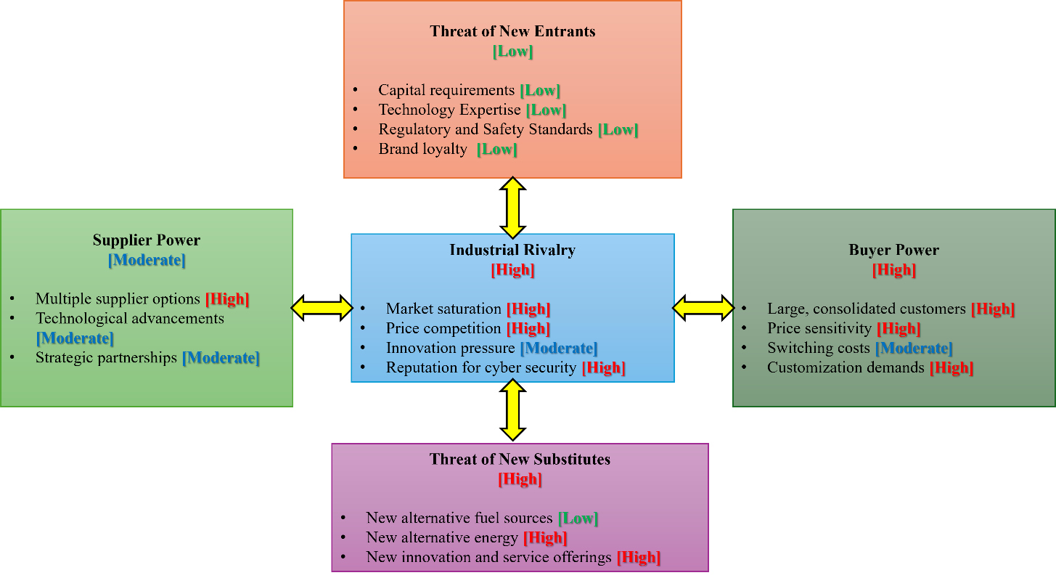*Sources: Pason Annual Information, 2023;*

*Pason Annual Report, 2023;*

*Pason Information Circular, 2023;*

*Management’s Discussion and Analysis Pason, Q3 2024;*

*Investor Presentation, Q3 2024;*

*Annual Special Meeting of Shareholders, 2024;*

The high threat of new substitutes could reduce demand for hydrocarbons, impacting Pason’s financial performance. In addition, the high level of industrial rivalry with one of the reasons related to a reputation for cyber security, could lead to data breaches and reputational damage, making it more challenging to compete and maintain customer trust while increasing operational costs for Pason.

**SWOT Analysis**

|  |  |
| --- | --- |
| **Strengths** | **Weaknesses** |
| * Global presence * More than 40 years of operation * Outstanding financial profile * Acquisition of IWS and Energy Toolbase * Drilling & completion activity * Distinctive technology and service offerings * New technology development * Leading economic modeling software tool * Growing control system sales pipeline * Strong Safety Culture * Environmental Responsibility * Advanced cyber security rating (Bitsight score of 790) | * Difficulties in integrating administration due to the acquisition of IWS and Energy Toolbase * Total Recordable Injury Rate (“TRIR”) of 95% * Highly dependent on attracting and retaining qualified workforce |
| **Opportunities** | **Threats** |
| * Government policies incentivize additional energy storage * Demand for renewable energy * Global demand for oil and gas * Customers’ demand for deploying data-driven automation and analytics technologies in their operations | * Volatility in commodity prices * Global geopolitical instability and recession risk * Potential security breaches, viruses or malware, cyber security attacks * Computer or telecommunication errors * Credit and liquidity risk * Availability of Raw materials * Regulatory and Policy Risks * Alternative Energies Risk * Natural disasters, energy blackouts, operating malfunctions, * Human error, internal or external misconduct * Supplier relationships * Global supply chain disruptions * Patent infringement lawsuit |

*Sources: Pason Annual Information, 2023;*

*Pason Annual Report, 2023;*

*Pason Information Circular, 2023;*

*Pason Sustainability Report, 2023;*

*PSI Amended and Restated Bylaws;*

*Investor Presentation, Q3 2024;*

*Management’s Discussion and Analysis Pason, Q3 2024;*

*Annual Special Meeting of Shareholders, 2024;*

The acquisition of Intelligent Wellhead Systems (IWS) and Energy Toolbase (ETB) is likely to be an opportunity for Pason to take advantage of while dealing with the alternative energy risk. However, that acquisition also presents challenges in integrative administration. In addition, the rising customers’ demand for deploying data-driven automation and analytics technologies in their operations drives Pason to make an effort to maintain their Advanced cyber security rating, mitigating Potential security breaches, viruses or malware, and cyber security attacks.

Using the environmental scanning we did above (PESTLE, Porter’s Five Forces & SWOT), we have identified two (2) biggest problems/risks and/or opportunities that Pason is currently facing.

1. **Pason is facing an alternative energy risk.** Concerns about climate change have resulted in the public opposing the continued exploitation and development of fossil fuels. It is likely that in the future, environmental requirements could result in reduced demand for hydrocarbons and increased demand for low-carbon energy, which could have a significant effect on Pason's business and financial condition.
2. **Pason is facing a potential security breach risk.** Despite Pason’s efforts to protect its IT infrastructure and data, there are potential threats, including natural disasters, cyberattacks, malware, human error, or other disruptions that could lead to the data and other electronic information stored in Pason’s IT infrastructure being accessed, publicly disclosed, lost, or stolen. Such occurrences could negatively affect Pason’s business and financial performance in the form of loss of revenue, increased operational costs, reputational damage, or litigation

**Impact to Profit**

Both risks present the potential for revenue loss and increased costs, if it is not planned and managed carefully. The energy transition may reduce demand for Pason’s core services, while a cybersecurity breach could lead to significant operational and reputational costs.

A proactive measure should be in placed to mitigate these risks like investing in renewable energy ventures and enhancing Pasons’s Cybersecurity to retain its customer trust, and diversify revenue streams, potentially creating future growth opportunities. Details of this are outlined in our recommendations.

**The Value Chain of Pason Systems Inc.**

**Differentiated Strategy**

|  |  |  |  |
| --- | --- | --- | --- |
| **Finance**   * Financial Management * Equity Investments * GAAP Compliance | | |  |
| **Human Resources**   * Recruitment * Health and safety * Succession planning | | |  |
| **Support Services**   * Audit Committee * Procurement * Insurance | | |  |
| **Board of Directors**   * Voting Rights * Shareholder’s Meeting * Stakeholder Engagement * Decision-making   **Executive Management**   * Leadership * Strategic Planning * Business Ethics * Business Development   **Research and Development**   * Innovation * Development of new technologies | **Service Operations**   * Drilling * Solar and Energy Storage * Energy Toolbase   **Technology Operations**   * Hardware and software * Drilling Data * Communications * Analytics & Other * Mud Management & Safety * Intelligent Wellhead Systems * Sales & Modeling Software   **Legal Systems**   * Intellectual Property * Litigation and Proceedings * Material Contracts | **International Operations**   * Suppliers * Raw materials & products * Supply Chain management * Joint Venture * Subsidiaries   **Risk Management**   * Cybersecurity * Climate Change * Market & Foreign Exchange * Human Error * Sustainability * Health, safety and Environment | Firm Profit  Firm Profit |

|  |  |  |  |  |
| --- | --- | --- | --- | --- |
| **Resources and Capabilities** | | **Hi** | Short-term valuable resources | **A B C D E F G**  Strategic  resources |
| **A** | Board of Directors |  |
| **B** | Executive Management | **Value Generation**  **(Valuable + Rare)** |
| **C** | Research and Development |  |
| **D** | Service Operations |  | Entry resources | Asymmetries |
| **E** | Technology Operations |  |
| **F** | International Operations |  |
| **G** | Risk Management | **Lo** |

Resources and Capabilities Matrix Assessment (Barney, 1991)  **Lo**   **Hi**

**Sustainability**

**(Inimitable + Non-substitutable)**

Pason Systems Inc. differentiated itself as falling on the quadrant of strategic resources which means that it competes directly with other oil and gas companies through its high value generation and high sustainability resources. Its focus on innovation, leadership, and value-added technological operations makes it valuable and rare. Moreover, the integration of intellectual property, advanced service and technological operations, and outstanding international operations makes these resources hard to replicate or substitute, thereby sustaining its competitive advantage.

**Resources and Capabilities**

| **Resources** | **Capabilities** |
| --- | --- |
| Brand name | Trusted and established a reputation for over 40 years |
| Capital | High-end instrumentation and data services to operators, contractors, and other oilfield service companies |
| Global Presence (North America, South America, Central America, Middle East) | High-value energy services and end-to-end technology |
| Existing Suppliers, Crude Oil and Product Inventories Drilled and Uncompleted Wells (DUCs) | Efficient supply chain management and maintaining operational continuity |
| Acquisition & Investments | Expansion of Technology & Service Offerings  Development of economic modeling software tool |
| Research and Development | Development of new technologies |
| IT Infrastructure | Capture, Transmit, Process, and Store significant quantities of electronic information |
| Cyber Security | Protection for sensitive operational data and secure communications across systems |
| Common Shares | Voting rights for shareholders, fostering governance and accountability |
| Board of Directors | Decision-making and business ethics |
| Investors and Joint Partnerships | Securing funding and investments in the oil and gas industry |
| Highly-skilled diverse workforce | Creative and innovative pool workforce |
| Certified Safety Professionals | Compliance with safety and regulatory requirements |
| Insurance | Protection for personal injury, loss of life, business interruption, property damage, pollution, and other liabilities |

*Sources: Pason Annual Information, 2023;*

*Pason Annual Report, 2023;*

*Pason Information Circular, 2023;*

*Management’s Discussion and Analysis Pason, Q3_2024;*

*Investor Presentation, Q3 2024;*

*Annual Special Meeting of Shareholders, 2024;*

**Evaluating Pason Systems Inc.’s VRIO**

|  |  |  |  |  |  |
| --- | --- | --- | --- | --- | --- |
| Resource/  Capability | Is it valuable? | Is it rare? | Is it difficult to imitate? | Is it organized to capture its value? | Can it be a basis for competitive advantage? |
| Brand name | Yes | Yes | Yes | Yes | Yes |
| Capital | Yes | Yes | Yes | Yes | Yes |
| Global Presence (North America, South America, Central America, Middle East) | Yes | Yes | Yes | Yes | Yes |
| Acquisition & Investments | Yes | Yes | Yes | Yes | Yes |
| Investors and Joint Partnerships | Yes | Yes | Yes | Yes | Yes |
| High-value energy services and technology | Yes | Yes | Yes | Yes | Yes |
| Research and Development | Yes | Yes | Yes | Yes | Yes |
| Existing Suppliers, Crude Oil and Product Inventories Drilled and Uncompleted Wells (DUCs) | Yes | No | Yes | Yes | No |
| IT Infrastructure | Yes | No | No | Yes | No |

*Is the resource/capability … and is the firm …*

Yes

Yes

Yes

Yes

**Sustained Competitive Advantage**

Organized to capture value?

Costly to imitate?

Rare?

Valuable?

No

No

No

No

Temporary Competitive Advantage

Temporary Competitive Advantage

Competitive Parity

Competitive Disadvantage

VRIO Framework

(Barney, 1991)

Pason Systems Inc.’s competitive advantage comes primarily from its brand name, global presence in multiple regions, acquisitions and investments coupled with strong investors and joint partnerships, and innovations that help it compete and succeed against its rivals. However, simply having existing suppliers, crude oil and product inventories, and drilled and uncompleted wells (DUCs) isn’t enough to beat its rivals. Pason Systems Inc. should now focus on mitigating its risks and improving its IT and supply chain management to further position its competitive advantage in the market.

**Recommendation No. 1:**

**Establish Integration Procedures for the Newly Acquired Companies (IWS and ETB)**

After the acquisition of Intelligent Wellhead Systems (IWS) and Energy Toolbase (ETB) at the beginning of 2024, Pason has difficulties in integrating administrative, financial reporting, operational and information systems and managing newly-acquired operations; difficulties in maintaining uniform standards, controls, procedures and policies through all of the Company’s operations; entry into markets in which Pason has little or no direct prior experience; difficulties in retaining key employees of the acquired operations; disruptions to Pason’s ongoing business; and diversion of management time and resources. Any of the foregoing could adversely affect the Corporation’s financial condition and results of operations (*Source*: *Management’s Discussion and Analysis Pason, Q3_2024).*

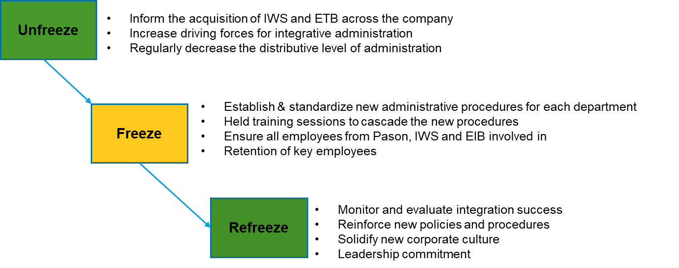To improve the administrative management of the company, especially for the integration with IWS and ETB, we recommend that Pason establish a planned approach to manage the change in administrative management. To achieve integration in administrative management, the plan should be echoed across all levels of the organization, from senior management to internal staff. This is a kind of strategic change and a planned change. Planned change processes often involve large groups of people and step-by-step or phase-by-phase activities that unfold over a period (Rice University, 2019). We propose using Lewis’s Change Model to implement this change.

**Lewin’s Change Model Process**

Source: (Rice University, 2019)

However, there will be several challenges Pason can face while implementing the above planned change. These challenges can stem from the complexity of integration, the human and organizational aspects of change management. During the integration process for the newly acquired companies, the challenges Pason is likely to face including: resistance to change from staff in all companies (IWS, ETB and Pason), communication breakdowns, and challenges in merging administrative and operational systems. Employees may resist changes to established new routines, and cultural differences between three companies could also create conflict. The technical compatibility problems and data migration challenges can complicate the systems’ integration, while operational disruptions may impact ongoing business of Pason. Moreover, aligning strategic goals and ensuring compliance across all companies will require significant effort. To mitigate these challenges, Pason should prioritize clear communication, involve leadership from all companies, implement phased integration, provide employee support, and continuously monitor progress to adjust strategies as needed.

**Controlling No. 1:**

**Monitor the effectiveness of Integration Procedures for Newly Acquired Companies**

To monitor the effectiveness of the new establishment for integration administrative after the acquisition of IWS and ETB, Pason should develop some standards to assess the new procedures, ensuring the company's continuous and effective operations.

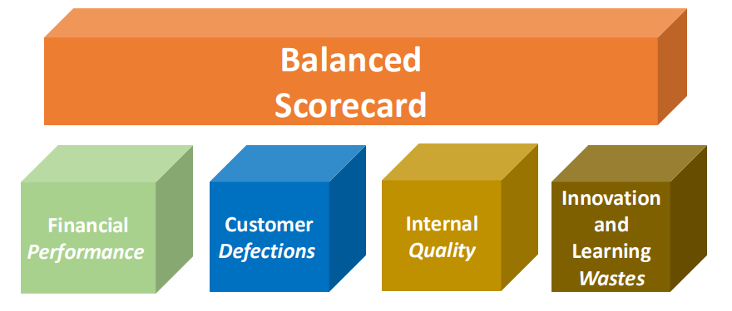

Balanced Scorecard

*Source: (SAIT Module 10, 2024)*

Designing the balanced scorecard, Pason can control its planned approach to monitor the effectiveness of integration procedures for newly acquired companies. Here is our proposed control model:

| **Scorecard** | **Objectives** | **Measures** |
| --- | --- | --- |
| Finance | Improve financial performance post-acquisition | Return on Investment (ROI) will increase by 10% in the first year after the acquisition |
| Optimize costs for administration | The cost-to-revenue ratio will reduce by 5% in the first year after the acquisition |
| Increase revenue from new acquisitions | Revenue will increase 5-7% in the first year after acquisition |
| Improve cash flow | Positive cash flow from operations |
| Customer | Retain key customers from IWS and ETB | Retain 90% of customers from IWS and ETB |
| Ensure customer satisfaction by integrating administrative | Not more than 3% of customer complains |
| Internal process | Achieve successful integration of administrative systems | 100% systems integration within 6 months |
| Maintain operational continuity | 99% uptime during integration |
| Learning & Growth | Number of training hours per employee | Minimum of 40 hours per employee per year |
| % of employees trained on new systems | 100% trained within 6 months |

*Source: (SAIT Module 10: Control, 2024)*

**Recommendation No. 2:**

**Improve Cyber Security to Safeguard Pason Systems Inc.’s Operations**

Pason’s cyber security is well-positioned as of 2024 as it takes measures and makes meaningful investments to protect the security and integrity of its IT infrastructure and data. Pason has not experienced any material losses relating to cyber-attacks or other information security breaches in the last three (3) years. In 2023 alone, it achieved an average cyber security BitSight score of 772, a level considered to be advanced. Pason’s cyber risk oversight is conducted by the Board’s Audit Committee, which receives information security updates from senior leadership on a quarterly basis. The Company undergoes external audits such as SOC 1 Type II and SOC 2 Type II, and its cloud-based environment is continuously monitored internally by Pason’s security team and externally by a third-party provider (Pason, 2023).

However, there is a risk that these measures may not fully protect against a potential security breach, which could have a negative impact on the Company’s ability to operate or its reputation. Natural disasters, energy blackouts, operating malfunction, viruses or malware, cyber security attacks, theft, computer or telecommunication errors, human error, internal or external misconduct, or other unknown disruptive events could result in the temporary or permanent loss of any or all parts of the IT infrastructure or data. There is a risk the data and other electronic information stored in Pason’s IT infrastructure could be accessed, publicly disclosed, lost, or stolen. Such occurrences could negatively affect Pason’s business and financial performance in the form of loss of revenue, increased operational costs, reputational damage, or litigation (Pason, 2023).

To ensure that Pason is prepared for this potential security breach or contingencies that might happen in the future, there is a need for Pason to craft a plan that should be in place in case these significant scenarios happen. We suggest that the company implement a contingency plan. According to Rice University, Contingency Plans are created to deal with events that might come to confront the organization (e.g., natural disasters, terrorist threats). An alternative course of action is to be implemented if events disrupt a planned course of action (Rice University, 2019).

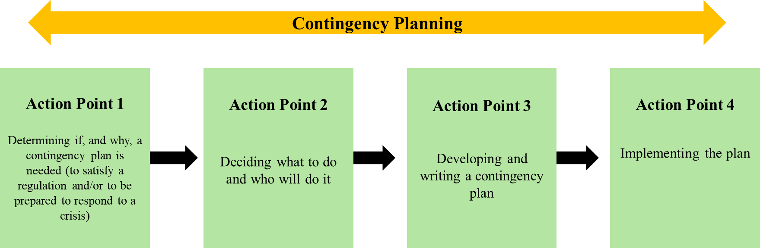

**Contingency Planning Four-Step Process**

*Source: (Hollingsworth, 1991)*

No matter what crisis is being considered, the first rule should be to base the contingency plan on realistic expectations (Hollingsworth, 1991). If Pason is prepared to initiate a rapid response to a security breach, it appears to be ready to quickly recover from the breach or at least minimize adverse effects to its revenue, operational costs, reputational damage, or litigation. Pason can better safeguard its business and continue operating smoothly, even in the face of unexpected challenges.

**Controlling No. 2:**

**Monitor Contingency Event Indicators and Implement the Plan, if necessary.**

Given the risks of Pason in its cybersecurity, Pason must integrate a strong control system across its IT infrastructure. This will ensure that the contingency plan is adhered to, and the company is prepared for a potential crisis. This contingent approach ensures that Pason meets its operational goals and safeguards its long-term sustainability and competitive edge in a rapidly evolving market (Hamby & Smith, 1972).

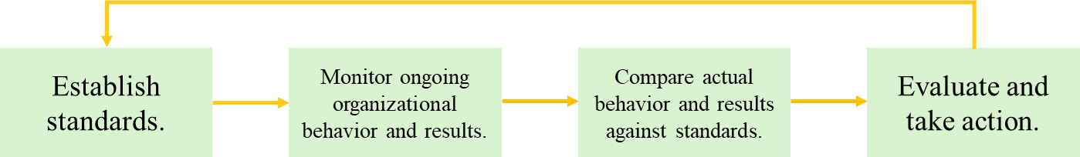

**The Traditional Control Model**

*Source: (Rice University, 2019)*

Using the traditional model of control, Pason can control its contingent plan based on a four-step process (Rice University, 2019). First, Pason should establish standards to protect its data, intellectual property, and overall IT infrastructure. Set clear performance metrics such as access control, authentic coverage, threat detection, anomaly response, vulnerability fixes, recovery efficiency, and incident response. Second, continuous monitoring of Pason’s IT infrastructure is important to detect any potential security threats. Regular audits and assessments should be implemented to ensure that all systems are performing according to predefined standards. Next, Pason should regularly evaluate its cybersecurity performance by comparing actual outcomes to established performance standards. All employees contributing to the KPI should be evaluated to measure if the goals are met. Lastly, once the evaluation occurs, Pason must decide whether to maintain its current course of action, revise standards, or take corrective measures. Here is our proposed control model:

| **The Strategic Objectives**  *Source: (SAIT Module 10: Control, 2024)* | | | |
| --- | --- | --- | --- |
| **Key Performance Indicators** | **Objectives1** | **End Result** | **Weight** |
| Access Control | Perimeter defense in depth using web and traditional firewalls with  intrusion prevention | Reduce unauthorized access attempts by 99%, with fewer than five incidents annually | 15% |
| Authentication Coverage | Multi-factor authentication for all critical applications | Achieve 100% MFA implementation with zero unauthorized access incidents | 10% |
| Threat Detection | Third-party monitored endpoint detection and response | Detect and resolve 95% of security threats within 24 hours | 10% |
| Anomaly Response | Continuous cloud anomaly detection and code scanning | Detect and address 99% of security anomalies in real-time | 10% |
| Vulnerability Fixes | Annual penetration testing of web applications | Identify and resolve 100% of critical vulnerabilities within 30 days | 15% |
| Recovery Efficiency | Disaster recovery time objective & and recovery point objective of no more than 24 hours | Resolve 100% of disruptions within 24 hours, meeting recovery time and point objectives | 20% |
| Incident Response | Advanced security operations center monitoring | Detect and respond to 100% of incidents within 15 minutes, resolve 98% within 24 hours | 20% |
| Total | | | 100% |

*Sources: 1Pason Sustainability Report, 2023*

*Fernandez & da Gama, 2008*

**References**

Barney, J. (1991, March). Firm Resources and Sustained Competitive Advantage. <https://journals.sagepub.com/doi/10.1177/014920639101700108>

Fernandez, L.J., da Gama, F. S. (2008). *Contingency Planning: A literature review*. ResearchGate. <https://www.researchgate.net/publication/230807504_Contingency_planning_-_a_literature_review>

Hamby, T.W., Smith, J.R. (1972). Contingency Planning for Drilling and Producing High-Pressure Sour-Gas Wells. Journal of Petroleum Technology 24 (03): 347–356. Paper Number: SPE-3512-PA <https://doi.org/10.2118/3512-PA>

Hollingsworth, W. (1991). *Contingency Planning: Implementation Is The Key*. International Oil Spill Conference Proceedings (1991) 1991 (1): 19–23. <https://doi.org/10.7901/2169-3358-1991-1-19>

Pason Systems Inc. (2023). Management’s Discussion and Analysis. <https://www.pason.com/investors/investor-information#analysts>.

Pason Systems Inc. (2023). Annual Report. <https://www.pason.com/investors/investor-information#analysts>

Pason Systems Inc. (2023). Information Circular. <https://www.pason.com/investors/investor-information#analysts>

Pason Systems Inc. (2024). Annual Special Meeting of Shareholders. <https://www.pason.com/investors/investor-information#analysts>

Pason Systems Inc. (2023). Management’s Discussion and Analysis Pason*.* <https://www.pason.com/investors/investor-information#analysts>

Pason Systems Inc. (Q3, 2024). Management’s Discussion and Analysis Pason*.* <https://www.pason.com/investors/investor-information#analysts>

Pason Systems Inc. (Q3, 2024). Investor Presentation*.* <https://www.pason.com/investors/investor-information#analysts>

Pason Systems Inc. (2023). Annual Information Form. <https://www.pason.com/investors/investor-information#analysts>

Pason Systems Inc. (2023). Sustainability Report. <https://www.pason.com/investors/investor-information#analysts>

Pason Systems Inc. (2014). Amended and Restated By-Law Number 1. <https://www.pason.com/investors/investor-information#analysts>

Rice University. (2019). Principles of management. OpenStax. <https://openstax.org/books/principles-management/pages/1-introduction>

SAIT. (2024). Module 4: Planning & Decision-Making / Managerial Mindset. In MNGT-255: Introduction to Management [MLB]. D2L/Brightspace.  [https://learn.sait.ca](https://learn.sait.ca/)

SAIT. (2024). Module 6: Innovation and Change. In MNGT-255: Introduction to Management [MLB]. D2L/Brightspace. <https://learn.sait.ca>

SAIT. (2024). Module 10: Control. In MNGT-255: Introduction to Management [MLB]. D2L/Brightspace.  [https://learn.sait.ca](https://learn.sait.ca/)